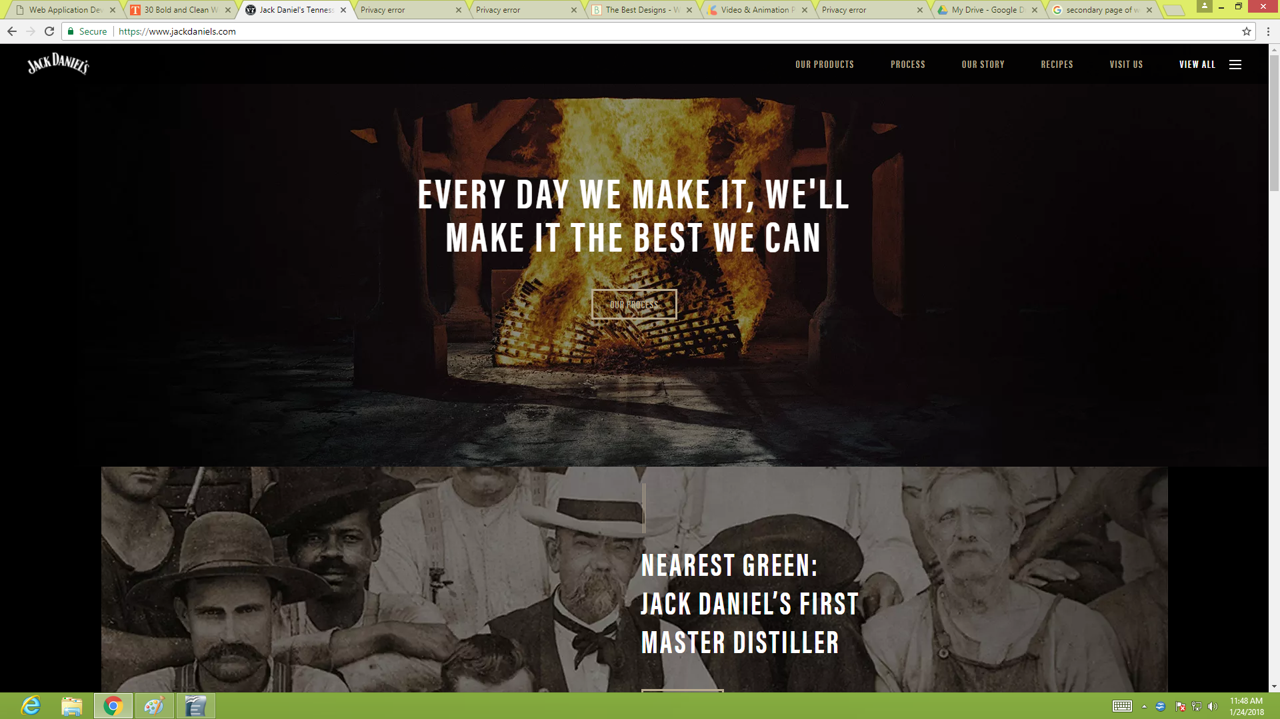
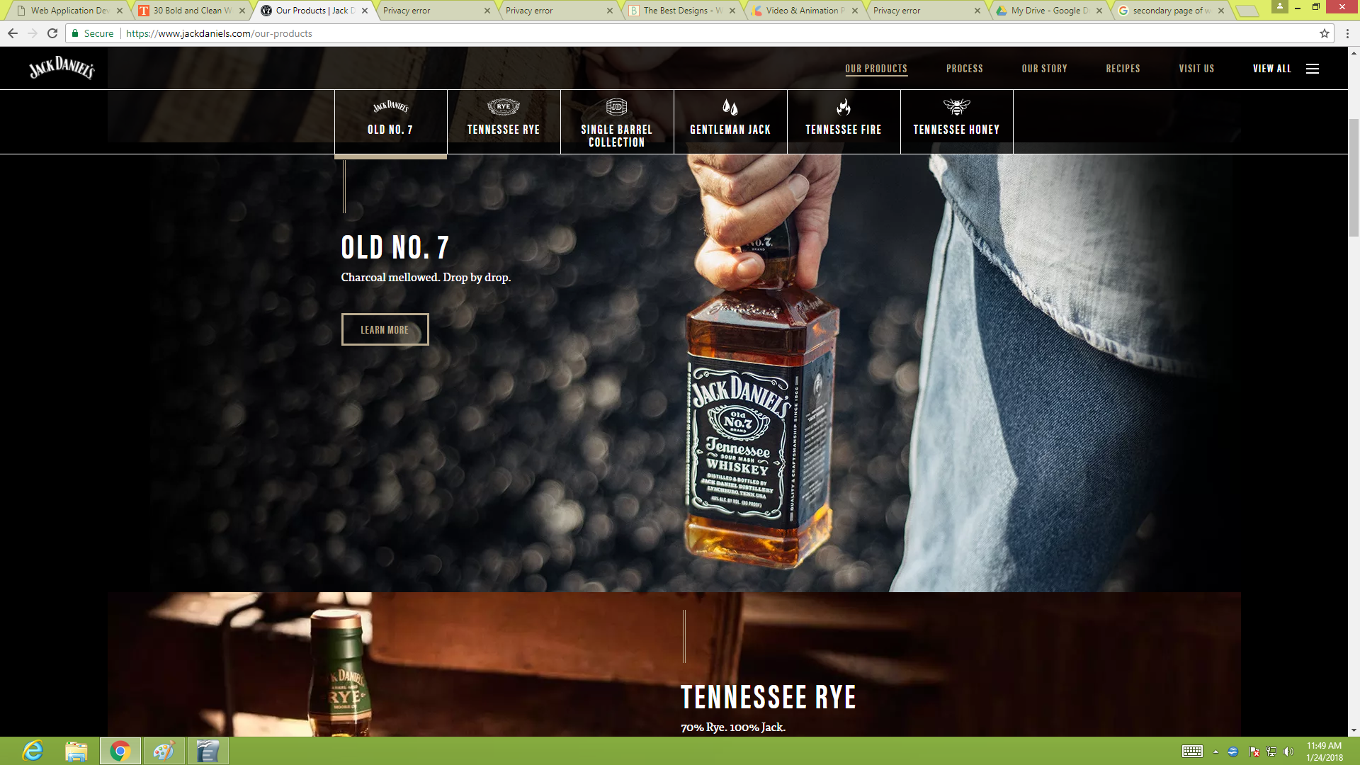
Banner
Same Color
Consistent navigation
menu shows current location
Utility links
Active white space

Once you get past the age verification, the black-and-white branding is carried throughout the home page, which greets you with a carousel featuring different varieties of the whiskey. The layout of the site attracts people most specially people who love to drink or people who loves whiskey

The Secondary page displays all the products for this websites, different kinds of Jack Daniel flavors.

Poor Design Website
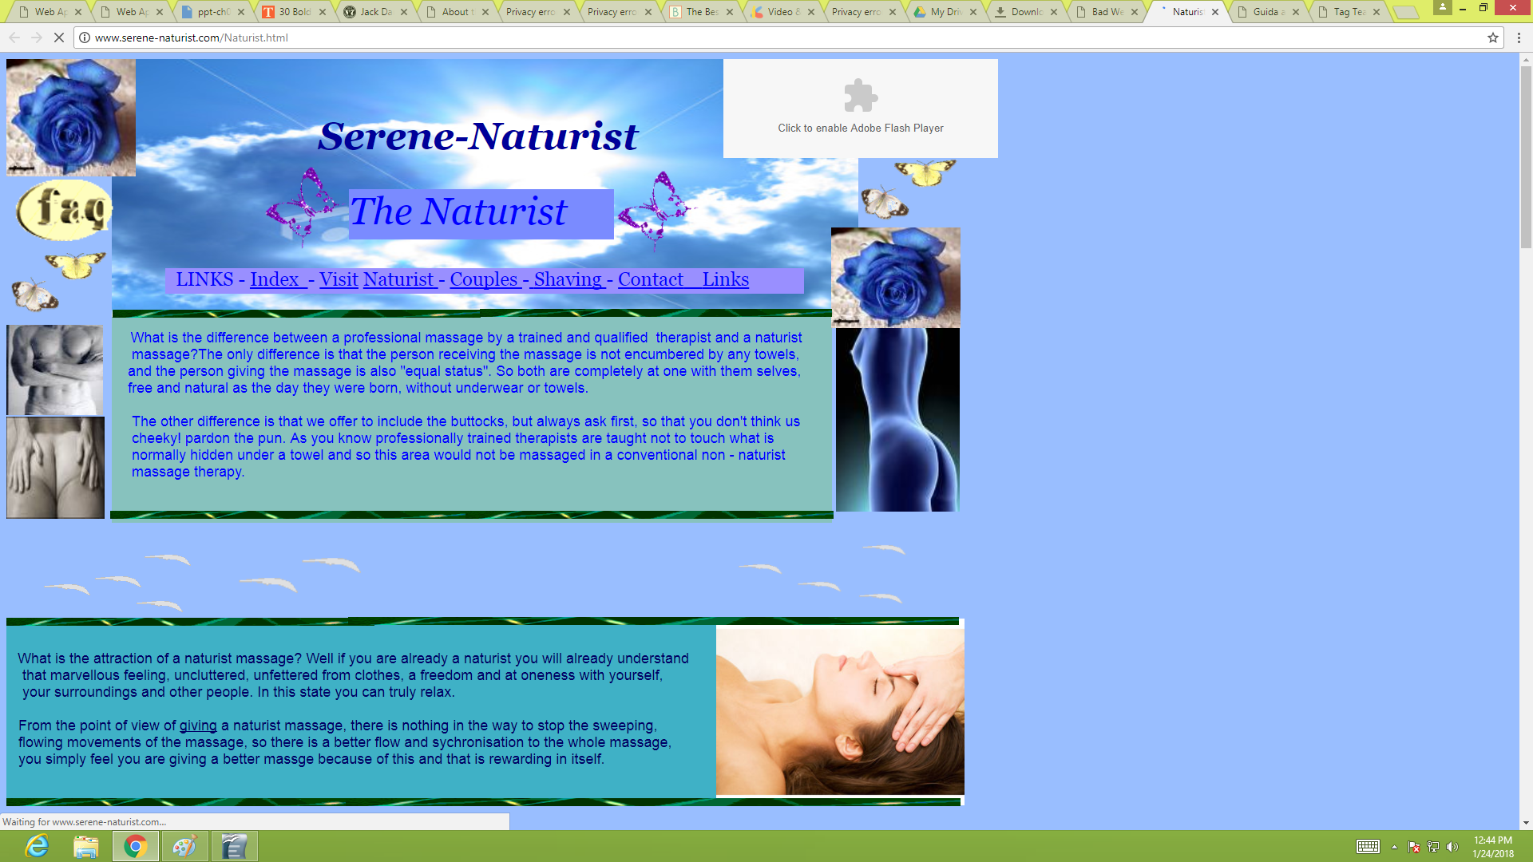
The Background
Doesnt suit the content
The pictures are too compressed
Utility links is not properly designed
The website has no fixed page layout
Not enough content or information

3. Write a short essay critiquing a Web siteâ€™s design. Describe the structural layout of the site and determine whether information is presented clearly and is easily accessible.

In making layouts of website it must be beautiful but simple. By keeping your page simple, website will be easy to use. Pages should be well organize with a top down design so that visitor can easily browse thru the different section of the websites. Color should be crucial so visitor can be

